Why Kenya Should Embrace Conservation Agriculture Farming Practices to Boost Food Security

By

Dr Pascal Kaumbutho PhD CEng MIAgrE
Managing Director.
Agrimech Africa Ltd.
pascalgk@agrimechafrica.co.ke
www.agrimechafrica.co.ke

Like the rest of the continent of Africa, Kenya’s farmland productivity is dwindling. Kenya’s current agricultural development plans project a Food Security pillar that can only be achieved if Conservation Agriculture (CA) is aggressively adopted by farmers of all sizes. Indeed, farming the CA way has a new dimension of farming in a period of Climate Change, calling for Climate Smart Agriculture (CSA). There are two primary challenges, needing two primary solutions, whose sought impacts are highlighted below. CA is defined in the Box below. Applied appropriately, CA practice at smallholder farmer level looks like the pictures included here.
What is Conservation Agriculture (CA)? What is the contribution of Agricultural Practices to Climate-Smart Agriculture?
Conservation Agriculture (CA) is an ecosystem approach to sustainable agriculture and land management based on the practical application of three interlinked principles of:
- continuous none or minimum mechanical soil disturbance (no-till seeding/planting and no-till weeding);
- permanent maintenance of soil mulch cover (crop biomass, stubble and cover crops); and
- diversification of cropping system (crop rotations and/or sequences and/or associations involving annuals and perennials, including legumes for natural nitrogen fixation), along with other complementary good agricultural production and management practices.

CA enhances biodiversity and natural biological processes above and below the ground surface, which contributes to increased carbon sequestration, water and nutrient use efficiency, hence the improved and sustained crop production. FAO

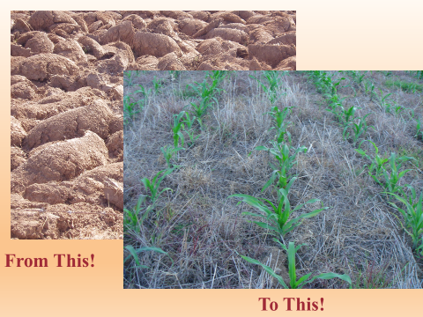

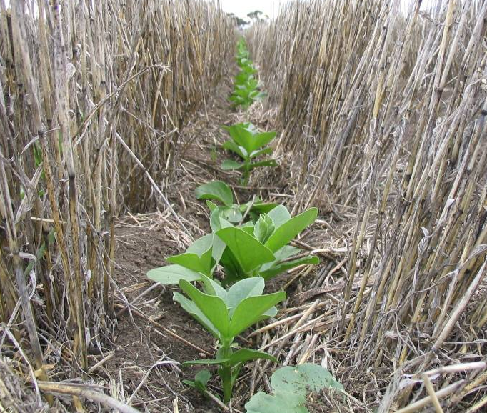

Figure 1: In today’s modern and mechanized farming, it is possible to plant crops without turning the soil like in the picture shown on the left. Future tropical farms that are soil-health conscious and climate smart will look like the two pictures to the right. Seeds are planted into un-ploughed land or into the old crop residues like shown, with conscious effort to practice crop rotation. Weeds are killed with environment-friendly herbicides and a capable machine is used to plant into the ground, causing minimum soil disturbance and creating excellent conditions for rain-water harvesting, without soil erosion.

Challenges | Solutions and sought impact
The Country is losing unforgivable volumes of fertile top soils that favour crop and livestock farming, to erosion, not only in sloppy, but all agricultural lands. Hard pans developed by hoe and mouldboard farming of the past cause flooding and erosion, to the detriment of sustainable farming practice and food security. Land is quickly becoming desert, or simply unable to withstand healthy cropping. The resulting behavior is one of shift cultivation and farmers wanting to farm on higher altitude lands, if not in forested areas like Mau and others of Kenya’s water-harvesting Hills. | Practicing CA means farmers fitting themselves in landscapes and learning ways of increasing soil health and productivity per unit of land (sustainable intensification), other than putting more land under production, as a way of increasing overall produce volumes available at harvest time. Farming the CA way means creating soil structures that prevent soil erosion where there is slope. It means planting trees to protect soils and creating clever tree-crop and livestock-crop mixes that keep the soil healthy, so that it can sustainably feed plants and animals alike. CA practice means leaving soil covered and previous crop harvested in a way that its roots enhance on-location (in-situ) rainwater harvesting, encouraging more percolation than runoff. Soils that are covered with mulch or cover crops, retain heathy soil fauna and pH, environments good for carbon sequestration and good for converting fertilizers and manure to forms palatable by the crops.
Farmers are aging and lonely in rural areas with the youth unwilling to take-on farming as a livelihood or as a business, some of them migrating to towns and cities in search for non-existent jobs. Farm productivity has fallen to levels that can hardly feed the population. Agro-processing factories running at a paltry, 10% of built capacity. | Conservation Agriculture (CA) is environment friendly and promotes farming in harmony with nature. Where a plough, several harrows and a planter are needed for establishing a crop, a single CA Direct Seeder (on un-ploughed land) needs only a fraction of the labour and machine power required, hence huge savings in getting the planting done. CA practices lead to upto 4 times the produce volumes from the same land. With farming made easier and inputs per tonne of yields achieved easier, farming will attract youth and help meet the dream of sustained food security.

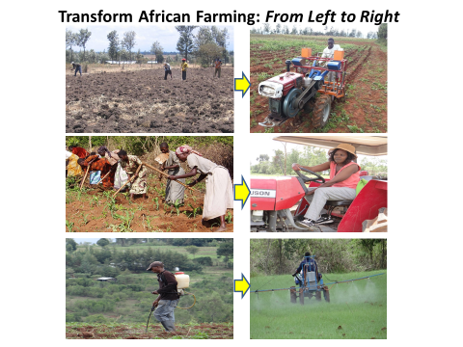
Figure 2: To attract youth to farming and to be able to farm effectively in a country where the average of a farmer is 55 years, Kenya and Africa must adopt ways of farming like sown on the right, to beat ways shown on the left. By shifting farming practice from left to right women’s farming burden will be taken by youth, happy to operate machines and make money from easier farming practices.

